Division Coordinators,
The below document describes how to create a team – for U10 and up this needs to be done by August 24th EVEN IF YOU ONLY HAVE ONE TEAM !!!
Support
Add a New Team (Allocate Players & Volunteers)

Team Builder
The Team Builder is used to allocate registered players to different teams within their division..

Steps to Create Teams:
- Once you're logged in you will have Division Coordinator rights that allow you access to the Teams functionality , click on the Teams button on the admin menu at the top of the screen. This will take you to your Teams Landing Page.
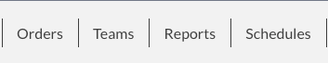
- On the Teams Landing Page, select the program and division you would like to create the team under (Make sure this is your division) from the drop down menus and click on the Click Here to Add New Team button.
- A pop up will appear giving you 3 options. Click Manual Team Creation.
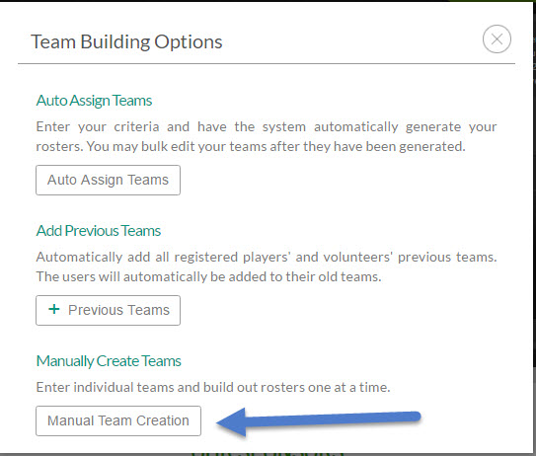
- Type in the number of teams and click Make Teams.
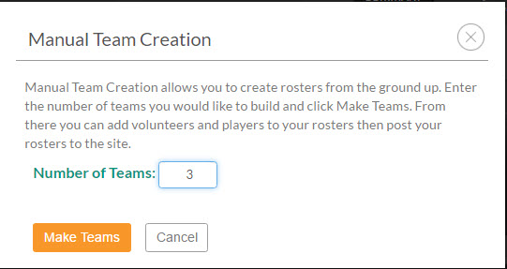
- Type in the team names and click Save Teams.
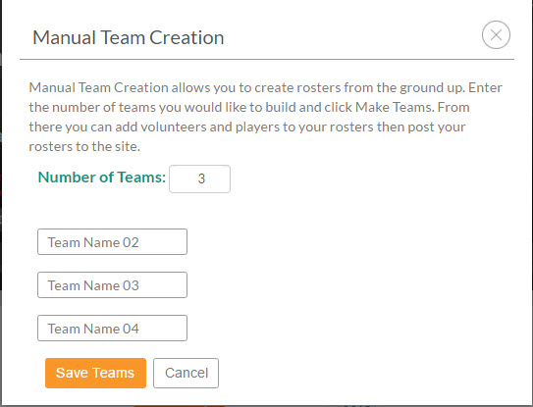
- To begin adding players and volunteers to a team, click the Edit button next to the team name and follow Steps 1 through 3 in our Team Wizard.
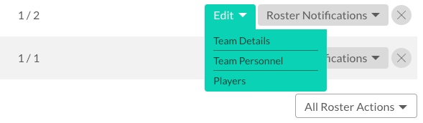
If you do not want to manually add teams, you can also use our Add Previous Teams or Auto Draftfunctions.
*Note: Once you have added a team on the Teams screen, this team will be added within the Team Directory under Team Central. Players will not be able to access their team page until you add them to the team and post the roster

